Identify the classes. Classify them as weak and strong classes and draw the class diagram for the specified Case Study

Table of Contents

Classes 2
User 2
Attributes 2
Methods 2
Expense 2
Attributes: 2
Methods: 2
Dashboard 2
Attributes: 2
Methods: 2
Settings 2
Attributes: 2
Methods: 2
AuthenticationManager 2
Methods: 2
Class Relationships 2
Class Diagram 3

Classes

User

Attributes: UserID, Username, Password, Email, BudgetLimit
Methods: Login (), SignUp (), ChangePassword (), SetBudgetLimit ()

Expense
Attributes: ExpenseID, UserID, Amount, Category, Description, Date
Methods: AddExpense (), ViewExpenseReport (), CategorizeExpense ()

Dashboard
Attributes: UserID, Expense Data
Methods: Generate Dashboard ()

Settings
Attributes: UserID, Theme, NotificationPreferences
Methods: ChangeTheme (), UpdateNotificationPreferences ()

AuthenticationManager
Methods: Verify Login (), Verify Signup (), GenerateOTP (), ResetPassword ()

Class Relationships
User has a Dashboard.
User can have multiple Expenses.
Settings are associated with a User.
Authentication Manager manages User authentication processes.

Weak and Strong Classes
Strong Classes: User, Expense, Dashboard, Settings
These classes have distinct attributes and methods, representing clear entities within the system.
Weak Class: Authentication Manager
This class is more of a manager or service class, handling specific processes rather than representing a distinct entity with attributes.

Class Diagram

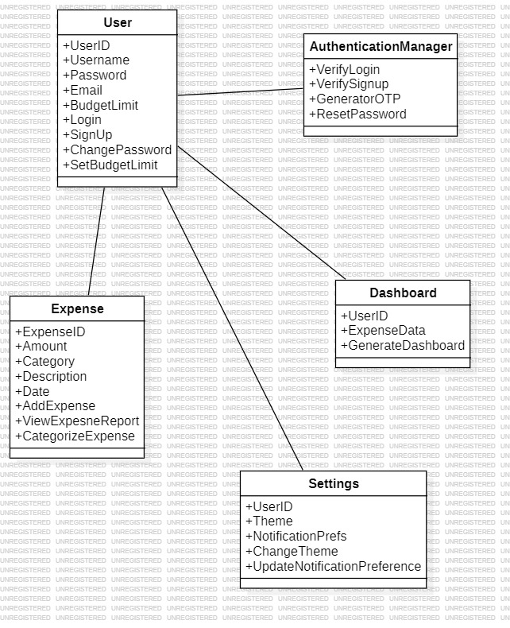
Figure 1:Expense Sharing App Class Diagram

